22nd June 2012

Ms Chow
No. 145-165 Standard Secondary School,
Tsuen King Circuit,
Tsuen Wan

Tel: 2493 7258 Fax: 2492 2496 mail:irene@ychlpyss.edu.hk

Dear Ms Chow,

Re: “The 30th Anniversary of YCH Lim Por Yen Secondary School” Supplement

Further to our conversation regarding the captioned supplement, we are pleased to submit the proposal for your consideration. Details are as follows:

Publication date | Date to be confirmed
Size | 1 x Full Page | Centre Spread | 4 x Full Page
Colour | 4 Colour
Gross | HK$207,400.00 | HK$477,020.00 | HK$829,600.00
Discount | Special discount
Net Amount | HK$35,000.00 | HK$70,000.00 | HK$128,000.00

Supplement Terms
- Ming Pao editorial team is responsible for write-up, interviews, editing and production of the supplement.

We sincerely hope that our proposal would meet with your favorable consideration. Should you agree with the above terms and conditions, please kindly sign and return as confirmation.

For assistance, please contact me at 2515 5419 / 9382 6505 or by fax at 2505 6055.

Proposed by Accepted by
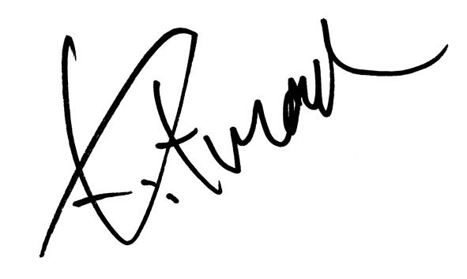 ____________________________
Kitman Chan Signed by Authorized Representative of
Senior Account Executive advertiser (With Co. Chop)
Name: _______________________

