記憶法

- 記憶法是怎樣運作的？

  - 檢查你的記憶

    - 關連測驗
閱讀以下二十項物件，然後依次序記下它們。
Wallpaper牆紙 | Scissors剪 | Power力量 | Perfume香水
Mountain山 | Nail指甲 | Elephant大象 | Safe保險箱
Skirt短裙 | Watch手錶 | Jail監牢 | Melon蜜瓜
String繩 | Nurse護士 | Mirror鏡 | Mongrel混血兒
Ice cream雪糕 | Plant植物 | Suitcase行李喼 | Engraving雕刻

    - 用一分鐘時間記下以下十項物件及它的編號。這個測驗的目的是要把其數字與物件關連起來。一分鐘完結後，請寫下答案。
- Atom原子 | - Tree樹 | - Stethoscope聽診器 | - Sofa梳化 | - Alley巷
- Tile瓦 | - Windscreen擋風玻璃 | - Honey蜜糖 | - Brush刷 | - Toothpaste牙膏

    - 數字測試
以不多於半分鐘的時間查看以下十五位數字組。在半分鐘過後，把它們依次序寫下來。
798465328185423 | 493875941254945
784319884385628 | 825496581198762

    - 電話號碼測試
以下是一系列的商戶及人物的電話號碼。請用不多於兩分鐘的時間把它們記下來，然後再寫下來。
名稱 | 電話號碼 | 名稱 | 電話號碼
Body shop | 27875953 | 媽媽 | 57813702
Tennis partner | 66407336 | 嘉禾院線 | 21322132
天文台 | 1878200 | 大富豪 | 28284466
萬昌盛 | 22429111 | 童軍總會 | 23773300
花店 | 27258397 | 彩龍船 | 24952600

    - 撲克牌測驗
這個測是要測試你的記憶容量。請以不多於五分鐘記下五十二張牌及其次序。

    - 面相測驗
用不於兩分鐘時間把以下的人物及其名字記下來。

    - 日期測驗
這個是你的最後一個測驗。以下是某些特別事件的發生日期。請用兩分鐘時間把它們記下來。並回答問題。
 | 1666 | 倫敦大火
 | 1770 | 貝多芬出生
 | 1215 | Signing of Magna Carta
 | 1812 | 第二次獨立戰爭
 | 1454 | 第一次印刷
 | 1815 | 滑鐵盧之役
 | 1608 | 發明望遠鏡
 | 1905 | 愛因斯坦相對論
 | 1789 | 法國大革命
 | 1776 | 美國獨立宣言

  - 記憶的節奏：在學前和學習後做回憶
    - 在學習的時候不斷做回憶
閱讀以下的文字
was | the | range
away | of | of
left | Beyond | and
two | Leonardo da Vinci | and
his | which | else
and | the | the
the | must | walk
far | and | room
of | of | drawing
and | could | small
that | the | change
當你閱讀完畢後，就請即寫下以上三十三個字。

      - 檢查你的回憶
- 測驗的第1至7個字
- 測驗最後的2個字
- 有多個字重復了多個一次
- 特別的字
- 在中間的字較難記憶

      - 小休是很重要的
- 小休能提高回憶性，可以有75%
- 若果沒有小休，記憶力減至50%
- 時間越久，記憶越減

      - 記憶的節奏
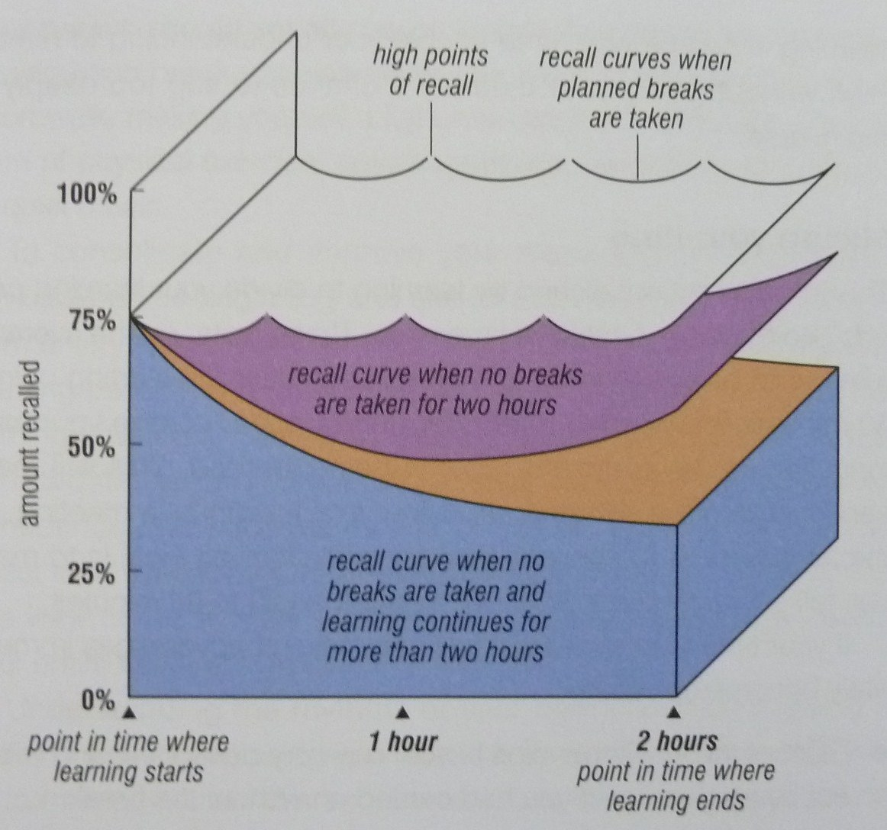
- 若果在一個20至50分鐘的學習時段內，其理解與回憶是最理想的。
- 「明白」是否能夠幫助到回憶？
- 回憶與明白是可以達至最佳的表現。

把你的學習時間好好去分割
- 要有小休
- 製造多一些「開始和小結」的高漲點
- 小休能更有效提高回憶與理解的作用
- 小休中的回憶能為你更有信心地接收新事物、更容易去把新事物作聯想和聯繫
- 小活動、非酒精飲品、做運動、自我提問、深層思考、輕音樂等，能有效增加記憶
- 整合思考、即時反饋、預覽、持續重溫－預覽周期
- 用雀鳥（府）的視野去看事物，依靠想像和聯想

      - 在學習後作即時的回憶
- 當你在學習後數分鐘內作回憶，你能夠保留更多的記憶
- 若果你在24小時內沒有重溫你所學過的東西，將有80%的資料會失去

      - 重溫與重覆
- 重覆、重溫、回憶
- 由短暫記憶到長期記憶：STM ® LTM = 5R (repetitions/reviews/recalls)
- 即時回憶 → 即日重溫 → 一周內重溫 → 一個月內重溫 → 三至六個月內重溫
- “sort things out” & “back to the grindstone”
- 高漲點會於當你停止閱讀／學習後的十分鐘內出現
- 用腦圖快速把學習資料記下來，這樣能夠幫助你更能有效去明白及回憶
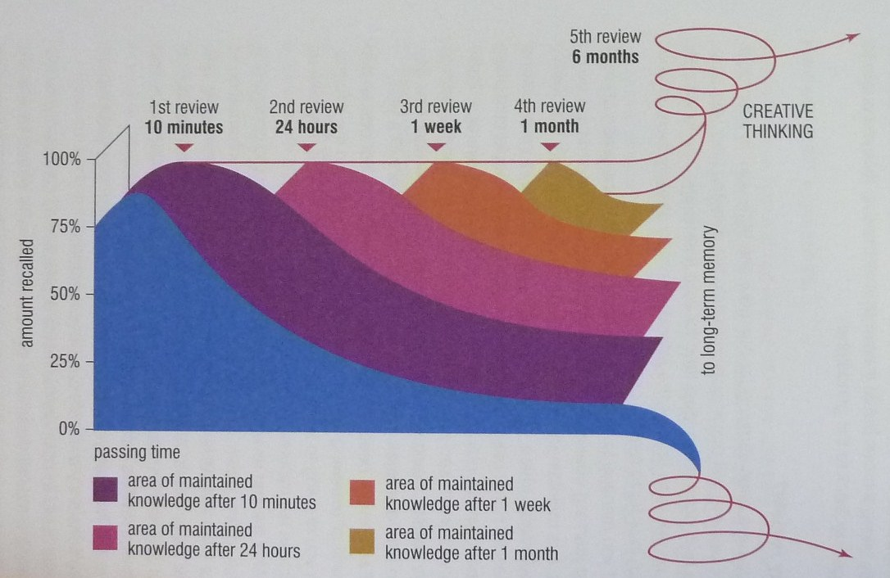

    - 記憶會隨著年紀而衰退嗎？
- 沒有證據顯示記憶會隨著年紀而衰退
- 年長的人（年齡大於24歲）已沒有再採用記憶技巧，也不會做溫習的習慣
- 左腦是掌管數學、語言、分析、邏輯、推理等能力
- 右腦是掌管節奏、音律、想像、色彩、空間感等能力
- 多加同時使用左腦和右腦能使你的想像力和聯想力更強大，幫助你去學習新事物

  - 想像力和聯想力與十二種記憶技巧
記憶術原則：想像和聯想
      - 這是第三種的記憶方法
      - 這十二種記憶技巧：SMASHIN’ SCOPE: senses感覺, movement移動, association聯想, sexuality性別, humour幽默, imagination想像, number數字, symbolism符號, colour顏色, order and/or sequence次序, positive images正面思維, exaggeration誇張
      - 主要的記憶想像詞匯
      - Purity
        - Crashing things together
        - Sticking things together
        - Placing things on top of each other
        - Placing things underneath each other
        - Placing things inside each other
        - Substituting things for each other
        - Placing things in new situations
        - Weaving things together
        - Wrapping things together
        - Having things talk
        - Having things dance
        - Having things share their colour, aroma, action

  - 連結系統
    - 舉例：假設你的家人請你到超市購買以下十樣物件，但不準你用紙記下來。
- A silver serving spoon鐵匙舀 | - Biological washing powder洗衣粉
- Six drinking glasses水杯六隻 | - Dental floss牙線
- Bananas香蕉 | - Wholemeal bread全麥包
- Pure soap肥皂 | - Tomatoes番茄
- Eggs雞蛋 | - Roses玫瑰

一分鐘過後，請你寫下你所需要買的物品（不需依次序）：
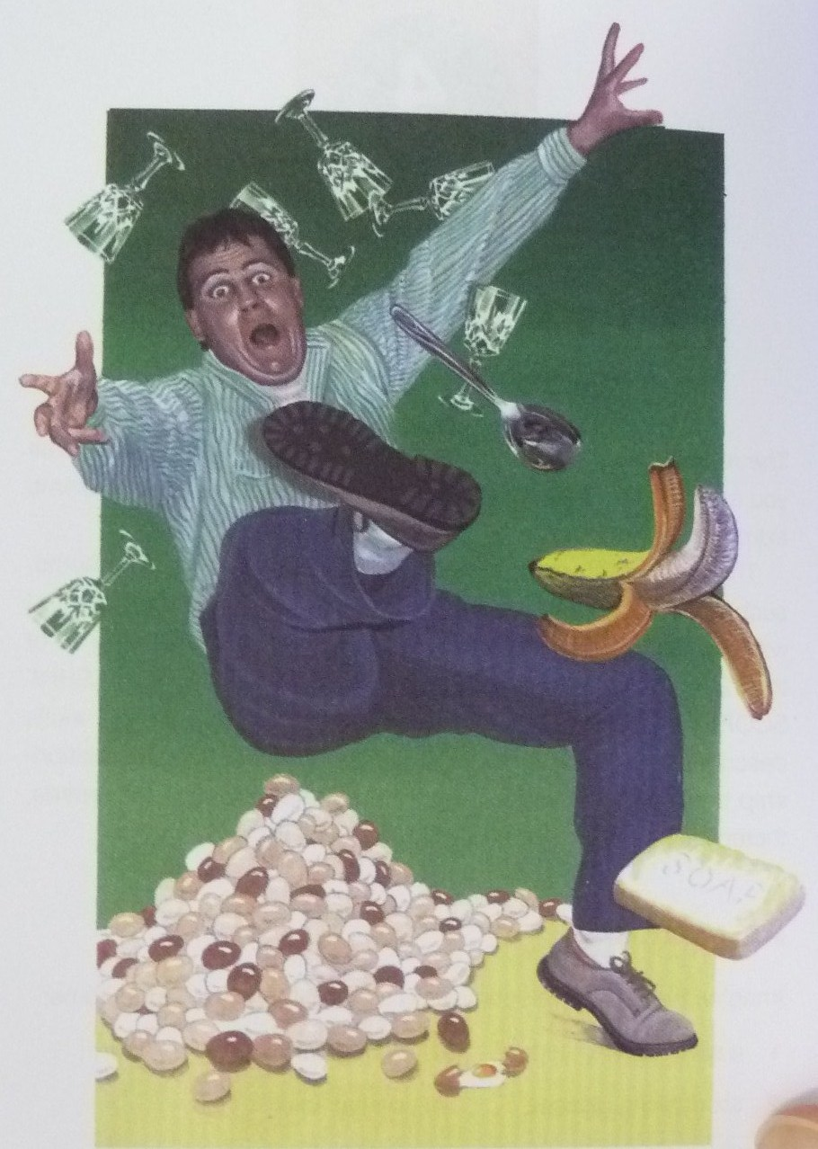
    - 把太陽中的「九」大行星聯結起來
首先去檢查一下你的知識和經驗
- 你是否有學過太陽系中的行星系統？如有，有多少次與及在哪個時候所學？
- 你是否知道現在的太陽系有多少粒行星嗎？
- 你知道它們的名稱嗎？
- 你知道它們的排列次序嗎？
請你把它們依次序寫下來。

    - 把太陽系記下來
      - Mercury: liquid metal thermometer
      - Venus: beautiful little goddess
      - Earth: she is living with you surrounded by garden
      - Mars: a red-faced, angry and war-like character is your neighbor
      - Jupiter: next is your best friend with a giant cow-lick “J” on his forehead
      - Saturn, Uranus, Neptune: Jupiter is wearing a T-shirt with a big word “SUN” emblazoned in flashing gold letters
      - Pluto: a Walt Disney dog sitting nearby Jupiter
倘若在你的腦袋中能把資料有系統記下來，像迷宮matrix一檥，這樣，新的資料／事物就會很自然地與舊的資料／事物聯繫起來，組成認知的樣式，能更容易去記憶和明白。我們是能夠改善我們的記憶技巧、增加我們的記憶容量和知識藏量、加速學習能力等。
  - 數字－圖形系統

    - 掛鈎系統
掛鈎系統可以被想像為特定數字的掛衣鈎架去掛上你不同的衣服。鈎架（編號）本身是不改變的，但掛上的衣服可以是有無限的改動。

    - 數字－圖形系統是怎樣運作的？
      - 去製作你自己的系統，因為智力minds是可以有無限多種的改變
      - 你所製作出來的聯想和影像是會在你的腦中存在一個很長的時間，甚至植入了在你的腦袋中
      - 每個數字皆有它們的形狀／形態
      - 用不多於十分鐘的時間去完成以下工作
數子 | 屬性 | 你自己的用字
1 | Paintbrush
2 | Swan
3 | Heart
4 | Yacht
5 | Hook
6 | Elephant’s trunk
7 | Cliff
8 | Hourglass
9 | Balloon on a stick
10 | Bat and ball

      - 數字－圖形記憶測驗
- 在以下的表格中填寫你剛才所用過的數字－圖形聯想法去寫下各樣物件
- 用耳去聽、去感受、去試味和臭味
- 把物件倒序記下來
- 用隨機的方法去提問任何一個物件。盡量回憶一下你所繪的圖像
- 把整個過程在你的腦海中重覆一次

      - 請記下以下事物：
- 交響樂
- 祈禱者
- 西瓜
- 火山
- 單車
- 日出
- 蘋果批
- 開花
- 太空船
- 麥田

      - 用誇張法、想像、性別與創意思考方法
      - Make the wildest, most colourful and exaggerated associations possible, projecting your images on to your internal screen, and thus consolidating them as you progress.

  - The number-rhyme system

    - How the number-rhyme system works
      - Resemble the shape of the number, devise key memory images for words that rhyme with the sounds of the words for the numbers.
      - Make them imaginative, colourful and sensual.
      - Suggestions:
- One: bun, sun, nun, Hun, run, fun
- Two: shoe, pew, loo, crew, gnu, coo, moo
- Three: tree, flea, sea, knee, see, free
- Four: door, moor, boar, paw, pour
- Five: hive, drive, chive, dive, jive
- Six: sticks, bricks, wicks, kicks, licks
- Seven: heaven, Devon, leaven
- Eight: skate, bait, gate, ate, date
- Nine: vine, wine, twine, line, dine, pine
- Ten: hen, pen, den, wren, men, yen
      - Draw your images in the spaces provide

    - Number-rhyme memory test
      - Test yourself on your chosen key rhyming images.
      - Run through the list from 1 to 10 in the usual numerical order.
      - Next, run through it in reverse order.
      - Then in random order.
      - Finally, pick the image “out of the air” and connect “their” numbers to them.
      - Repeat them, making each repetition faster and faster until you acquire such skill that your mind will instantaneously produce the image as soon as you think of the number.

    - Number-shape and number-rhyme memory test
      - Now you have two separate 1 to 10 systems. Decide which system you want to be which and immediately put it to the test.
- atom | - tree | - stethoscope | - sofa | - alley
- tile | - windscreen | - honey | - brush | - toothpaste
- glitter | - heater | - railway | - lighter | - wart
- star | - peace | - button | - pram | - pump

      - Below are three columns of 20 numbers. Complete each list, filling in next to the number the appropriate item from the list you have just memorized.

1 | 20 | 11
2 | 19 | 15
3 | 18 | 10
4 | 17 | 3
5 | 16 | 17
6 | 15 | 20
7 | 14 | 4
8 | 13 | 9
9 | 12 | 5
10 | 11 | 19
11 | 10 | 8
12 | 9 | 13
13 | 8 | 1
14 | 7 | 18
15 | 6 | 7
16 | 5 | 16
17 | 4 | 6
18 | 3 | 12
19 | 2 | 2
20 | 1 | 14

      - If at first it doesn’t work perfectly, it may be due to
- They are associations that you don’t like
- The associations are too close or too similar to each other
- Not enough exaggeration and imagination
- Not enough colour
- Not enough movement
- Weak links
- Not enough sensuality
- Not enough humour

  - The Roman room / memory palace system

    - Imagine this imaginary room
      - You imagine the entrance of your house and your room and then filled the room with as many objects and items of furniture as you chose.
      - Each object and piece of furniture serving as a link image, to which you attached the things you wished to remember.
      - The Roman room system is particularly amenable to the application o f the strengths of the left and right hemispheres of your brain.
      - The room can be entirely imaginary.
      - Things that please all your senses, items of furniture and objects of art you have always desired to possess in real life, foods and decorations that especially appeal to you.
      - Both your memory and creative intelligence will begin to work paraconsciously on ways in which you can actually acquire such objects in real life.

    - Your Roman room
      - On a piece of paper jot down quickly your first thoughts on the items that you would like to have in your own room, the shape and design of the room.
      - Draw your ideal memory room (on a separate sheet of paper), either as an artist’s daring or architect’s plan, drawing and writing in the names of items with which you are going to furnish and decorate it.
      - Select ten specific “loci” or locations for your memory items, building up to 20, 30, 50, adding rooms to your house.
      - Take a number of “metal walks” around your room, memorizing precisely the order, position and number of items in the room and, similarly, sensing with all your senses the colours, tastes, textures, smells, scents or aromas and sounds within your room, using the whole range of your brain’s abilities.
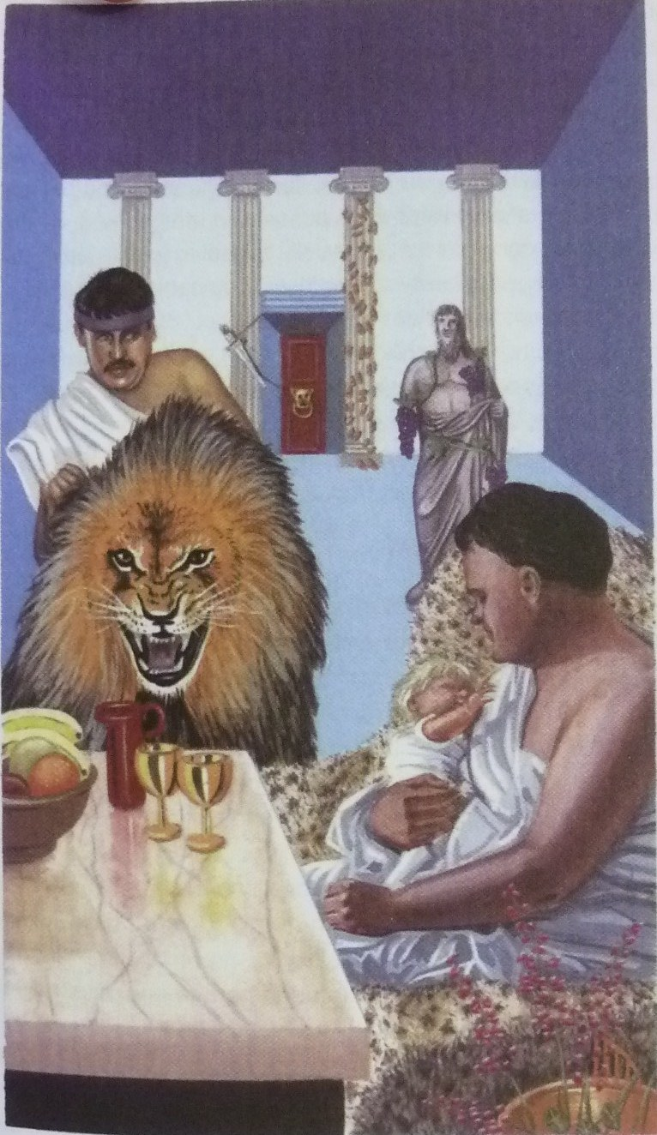
  - The alphabet system

    - Rules for constructing your alphabet memory system are simple:
      - Select a key memory image word that starts with the sound of each letter
      - Make sure the word is easy to remember
      - Make sure the word is easy to imagine
      - Make sure the word is simple to draw
      - If the letter itself makes a word when you say it (e.g. “I” makes the word “eye”, “J” jay)

    - Construct your alphabet system
      - pencil in your own initial alphabet system image words in the spaces provided
      - recheck your alphabet image words
      - select your final list and draw your images for them in the blank squares
      - when you completed your alphabet image word drawings, review them in exactly the same way as your have the previous memory systems

    - Suggested alphabet image words
- Ace | - Bee | - Sea | - Deed
- Easel | - Effervescence | - Jeep or Jeans | - H-bomb
- Eye | - Jay | - Cake | - Elastic
- MC | - Enamel | - Oboe | - Pea
- Queue | - Arch | - Eskimo | - Tea
- Yew | - Vehicle | - WC | - X-ray
- Wife | - Zebra

    - Double your memory power
      - Introductory memory systems: link, number-shape, number-rhyme, Roman room and alphabet.
      - They can be used either independently or in conjunction with another.

    - Icecubes
      - The words you associated were contained in a huge block of ice.
      - This visualization technique will drastically change the association pictures your have formed and will double the effectiveness of your system.

    - The ice factor in action

  - The major system

    - The major system’s special code
      - Make use of a different consonant or consonant sound for each number from 0 to 9 using a special code.
      - Number = associated code
 | = s, z, soft c | ‘s,’ or ‘z’, the first sound of the word “zero”, “o” is the last letter.
 | = d, t, th | ‘d’, ‘t’, have one downstroke
 | = N | ‘n’ has two downstrokes
 | = M | ‘m’ has three downstrokes
 | = r | ‘r’, the last letter in the word ‘four’
 | = L | ‘l’, can be thought of as either the Roman numeral for ‘50’ or an open hand, the index finger and thumb forming an ‘L’ shape
 | = j, sh, soft ch, dg, soft g | ‘j’, he mirror image of ‘6’
 | = k, hard ch, hard c, hard g, ng, qu | ‘k’, when seen as a capital, contains five number ‘7’s
 | = f, v | ‘f’, when handwritten, has two loops, similar to the number ‘8’
 | = b, p | ‘b’, ‘p’, the mirror image of ‘9’

      - The vowels a, e, i, o, u and the letters h, w and y do not have numbers associated with them. They are used as “blanks” in the key memory image words.
      - Create a key memory image word that can be immediately and permanently linked with the number it represents.
      - In selecting the ‘best’ words for this number, make use of the alphabet order to assist both in choice of word and in recall by using vowels letters.
      - The advantage of using this alphabet order system is that it can actually be ‘worked out’ from the basic information.

    - Initial major system exercise
      - Try to complete the words for numbers 10 to 19 in the table below using the alphabet order system.
      - Don’t just accept them, though – check each one carefully.
      - Use a strong noun or verb as it creates a good memory image on which to hang your information.

      - Initial 101 memory image words for the major system
- saw | - day | - Noah | - ma | - ra
- law | - jaw | - key | - fee | - bay
- daze | - dad | - dan | - dam | - dairy
- dale | - dash | - deck | - daffy | - dab
- NASA | - net | - nan | - name | - nero
- nail | - niche | - nag | - navy | - nab
- mace | - mat | - man | - ma’am | - mare
- mail | - mash | - mac | - mafia | - map
- race | - rat | - rain | - ram | - Ra-ra
- rail | - rage | - rack | - rafia | - rap
- lace | - lad | - lane | - lamb | - lair
- lily | - lash | - lake | - laugh | - lab
- chase | - chat | - chain | - chime | - chair
- cello | - cha-cha | - check | - chaff | - chap
- case | - cat | - can | - cameo | - car
- call | - cage | - cake | - cafe | - cab
- face | - fad | - fan | - fame | - fair
- fall | - fish | - fag | - fife | - fab
- base | - bat | - ban | - bam! | - bar
- ball | - bash | - back | - beef | - babe
- daisies

    - devising your own memory image words for numbers 101 to 1000
      - an alternative method is to stick with making every number into a letter and making a key memory image word from that combination of letters.
      - After certain of the more difficult words it has included:
        - A suggestion for a way in which an image might be formed from the word
        - Or a dictionary definition of the word, the definition including words or ideas that should help you form your image
        - Or ‘new’ definitions for words that place them in a humorous or unusual but certainly more memorable form
      - In the spaces provided you should write in your own key words for, or ideas about, the images you will be using.
      - If the combination of letters makes the use of single words difficult, double words have been used, such as ‘no cash’ for the number 276 (‘n’, hard ‘c’, ‘sh’)
      - In other cases it is necessary to include vowels (which have no numerical meaning) at the beginning of the word. The number 394 (‘m’, ‘p’, ‘r’) is represented by the word ‘empire’

    - Managing the major system when using this method
      - Check the major system list below carefully.
      - Making images for and remembering ten items each day.
      - Use both sides of your brain, increase and expand your imagination, creativity and awareness of your senses.
      - When words refer to ideas or concepts, take them to a more concrete level.
      - When words are similar in concept to previous words, make your images for them as different as possible.
      - Check words from a dictionary if you run into difficulty in selecting your key words. The suitable words must
        - Serve as a means of solidifying the images for you
        - Enable you to select the best possible images or words
        - Be of value in the improvement of your general vocabulary
        - Be of value in the improvement of your creativity
      - Memory image words for number 101 to 1000 (page 101)
    - How to increase everything you have learned so far by 1000 per cent
      - It is possible to create a memory system of large amount of words from basic words you have been absorbing.
      - Use the ice cube method. You simply coat, encase or colour sections of your major system with ice.
      - For each successive 100 you use a different ‘substance’.
      - Examples:
100-199 in block of ice
200-299 covered in thick oil
300-399 in flames
400-499 colored a brilliant and pulsating purple
500-599 made of beautiful velvet
600-699 completely transparent
700-799 smelling of your favorite fragrance
800-899 place in the middle of a motorway
900-1000 floating on a single cloud in a beautiful, sunny, clear blue sky

  - The card memory system

    - What is the secret?
      - Attach your key memory image for each card to the major system you have learned.
      - The first letter of the word for the suit as well as the number of the card in that suit; ‘c’ for club, ‘h’ for heart, ‘s’ for spade and ‘d’ for diamond.
      - The second consonant for the card word will be the consonant represented by the letter from the major system.

    - Memory image words for a standard pack of cards
      - Following are lists of the card and their memory image words.
Clubs |  | Diamonds |  | Hearts |  | Spades
CA | Cat | DA | Day | HA | Hat | SA | Sat
C2 | Can | D2 | Dan | H2 | Hen | S2 | Sin
C3 | Cameo | D3 | Dam | H3 | Ham | S3 | Sum
C4 | Car | D4 | Dare | H4 | Hair | S4 | Sear
C5 | Call | D5 | Dale | H5 | Hail | S5 | Sale
C6 | Cash | D6 | Dash | H6 | Hash | S6 | Sash
C7 | Cake | D7 | Deck | H7 | Hag | S7 | Sack
C8 | Café | D8 | Daffy | H8 | Hoof | S8 | Safe
C9 | Cab | D9 | Dab | H9 | Hub | S9 | Sap
C10 | Case | D10 | Daze | H10 | Haze | S10 | Seas
CJ | Cadet | DJ | Deadwood | HJ | Headed | SJ | Sated
CQ | Cotton | DQ | Deaden | HQ | Heathen | SQ | Satan
CK | Club | DK | Diamond | HK | Heart | SK | Spade
In this system, aces count as 1, the jacks and queens as 11 and 12, 10 counts as 0, the king as the name of the suit.

    - How does it word?
      - Whenever a card is called out, they associated that card with the appropriate number of the major system.
      - Using the major system as the pegs on which to hang the 52 items, you can clearly see that both the logical, analytical, sequential and numerical left side of your brain, and the imaginative, colourful, and rhythmical right side of your brain are being fully utilized.

    - How to increase your memory further still
      - Whenever a card is called out, you associate the image word for that card within a larger concept, such as the ice cube. When all the cards have been presented, run down the list of card memory words, noting those words that are not connected with the larger memory concept.
      - The other system for this kind of feat is to mutate, or change, in some way the card memory image word if that card is called.

  - Raising your IQ by using the long number memory system
Given a long number such as 95862190377 to memorize, most people will try a variety of strategies, including:
- Repeating the build-up continually as the number is presented, eventually getting bogged down in the very repetition process itself
- Subdividing the number into two or three number groups, eventually losing both the order and content of these
- Working out mathematical relationships between the numbers as they are presented, inevitably losing track of the original order or the numbers themselves
- Picturing the number as it is presented, the picture becoming more and more blurred as the long number is presented in its entirety
Instead of using the major system as a peg system for remembering list of 100 and 1000 you take advantage of its flexibility.

    - Pairing numbers with the major system’s memory image words
      - For example, 95862190377 is composed by 95-ball, 86-fish, 21-net, 90-base, 37-mac and 7-key
      - A brilliant, rainbow-colored ball bouncing with a loud ‘boing!’ off the head of a gigantic and beautifully colored fish that had just fought its way out of a very tangled and dripping-wet net, which was slowly collapsing to the base level of a pier, where it wrapped itself around a man wearing a fawn-colored and wind-blown mac, just as he was bending over to pick up a key, which he had dropped onto the pier with a loud clang.
      - Close your eyes and re-envision this little story.
      - Recalling the memory image words, transform them back into the numbers, and you will get:
b-9 l-5 f-8 sh-6 n-2 t-1 b-9 s-0 m-3 c-7 k-7 95862190377

    - Try it in threes
      - Try this with the number 851429730584
      - 851-fault 429-rainbow 730-cameos 584-lever
      - You can see in your mind some gigantic universal force that could cause a break or a fault in beautiful and shimmering rainbow-colored cameos, which are so heavy they need a gigantic lever to move them.
      - Close your eyes and show the little image story on your inner screen.
      - Recall the words and , transforming them, you get:
f-8 l-5 t-1 r-4 n-2 b-9 c-7 m-3 s-0 l-5 v-8 r-4 851429730584

    - Improvise
      - With a 16-digit number, such as 1582907191447620, you could make up the following 4-digit numbers and memory image words:
      - A red telephone, ringing loudly and melodically being thrown in a long and graceful parabolic curve into a basket, where an annoying person (a botherer) is jammed, bottom down (as in comedy films), while other people are throwing multicolored cushions in all kinds of different materials at him.
      - Close your eyes and imagine the story, then fill in the words and numbers in the space provided.

    - Using other pegging systems
      - Use both the Roman room system and the alphabet system, simply placing the words you had decoded from the long number either alphabetically or in your Roman room.

    - Some added benefits
      - Once you have mastered this skill, you will have improved your memory and your creative imagination even further and also actually raised your IQ.

  - The telephone number memory system

    - How to remember telephone numbers
      - ‘Translate’ each digit of the number you have to remember into a letter from the basic code for the major system.
      - Using the letters you have transcribed, make up catchy words and phrases that link you back to both the number and the person.

    - Solutions for difficult telephone numbers
      - Make up inappropriate words out of the numbers you have to deal with, then use the basic system, making absured and exaggerated images to link with the person whose telephone number you are trying to remember.
      - Example: one of your friends whose hobby is golf, is 491-4276. Then 49 (rap), 142 (drain) and 76 (cage).
      - Imagine that your friend rapping loudly on a drain, which has bars like a cage, with his golf club.

    - Over to you
      - In the space provided below, make a note of the names and telephone numbers of at least ten people or places you need to remember.

  - Memory system for schedules and appointments

    - Pegging your daily schedule
      - Either join shorter systems together , to make an appropriate total of 24, or use the firs 24 peg words in one of the larger systems.

    - Timetabling your weekly schedule
      - Take Sunday as day 1 of the week and ascribe a number to each of the other days:
      - Sunday-1, Monday-2, Tuesday-3, Wednesday-4, Thursday-5, Friday-6, Saturday-7

    - Simplifying the system
      - By ‘rotating’ the hours of the day to suit the times when you have most of your appointments.
      - For practical purposes, it is usually best to start with the system for your daily schedule, becoming skilled and familiar with it before moving on to the system for your weekly schedule.

  - Memory system for important historical dates
      - Make a word of the date.
      - In most cases, there is no point in including the ‘1’, representing the thousand.

  - Remembering birthdays, anniversaries and days

    - How the system works
      - The months are assigned the numbers 1 to 12 and given the appropriate memory image word for the major system.
January - Day | February - Noah | March - Ma | April - Ra
May - Law | June - Jaw | July – Key | August - Fee
September - Bay | October - Daze | November – Dad | December – Dan
      - Form an image that links the month and day words and the date you wish to remember.
      - Historical dates can become just as easy to remember.

  - Memory systems for vocabulary and language

    - Improving your word memory – general tips
      - Some more tips for how to improve your word memory.
        - Browse through a good dictionary, studying the ways in which the prefixes, suffixes and roots of the language are used. Whenever possible, use association to strengthen your recall.
        - Introduce a fixed number of new words into your vocabulary every day. New words are retained only if the principle of repetition, as explained earlier, is practiced. Use your new words in context and as many times as possible after you have initially learned them.
        - Consciously look for new words in the language. This directing of your attention, know as mental set, leaves the ‘hooks’ of your memory more open to catching new linguistic fish.

    - Improving your word memory – specifics
      - Associate sounds, images and similarities using the fact that certain languages are grouped in ‘families’ and have related words.
      - Imprint the words on your memory you can associate the sound of it with the phrase ‘Where to go?’
      - Foreign languages are more approachable when one realizes that they form groups.
      - All European languages (with the exception of Finnish, Hungarian and Basque) are part of the Indo-European group and contain a number of words that are similar in both sound and meaning.
      - A knowledge of Latin is of enormous help in understanding all the Romance languages, in which many of the words are similar.
      - Apart from Latin, Greek and French, the rest of English is largely Angle-Saxon, and German.
      - Learning languages need not be the frustrating and depressing experience it so often is.

    - The 100 basic words that make up 50 percent of all conversation
      - To get head start in learning is to realize that, in most languages, 50 percent of all conversation is made up of only 100 words.
      - Here below are the 100 most used words in different languages.
      - Adults can learn languages as well as children. Children simply open their minds more to the language and are not afraid to make mistakes.
      - They repeat and make associations with the basics, listen more attentively, copy and mimic and generally have a thoroughly good time without as much instruction as we adults think we need.

  - Remembering names and faces
Paul Smith | Roger Waters
Christian Dover | Sebastian Bach
Jackson Michael | Angry Bird
胡爾諾 | 李雲仇
郭德宏 | 曾義弓
劉寶玲 | 蔡茹玉
范憎祺 | 冼志錦
覃雪清 | 達也真彥
畢達哥拉斯 | Apfel Saft

    - The ‘social etiquette’ method
      - Two simple things of you:
        - An interest in the people you meet
        - Politeness
      - The rules being structured formally only to enable the people to meet and remember one another.
        - Mental set
        - Observe
        - Listen
        - Request repetition
        - Verify the pronunciation
        - Request the spelling
        - Your new hobby – derivations
        - Exchange cards
        - Repetition in conversation
        - Repeat internally
        - Check during longer breaks
        - Repetition at parting
        - Reviews
        - The reversal principle
        - Pace yourself
        - Have fun
        - The ‘plus one’ principle

    - The mnemonic names and faces memory method
      - The steps are as follows:
        - Make sure that you have a clear mental image of the name of the person you want to remember.
        - Make sure you can actually ‘hear again’ the sound of the person’s name.
        - Very carefully examine the face of the person you have been introduced to, noting in detail the characteristics outlined below.
        - Look for facial characteristics that are unusual, extraordinary or unique.
        - Mentally reconstruct the person’s face, using your imagination in the way that a cartoonist does to exaggerate any noteworthy features.
        - Associate – using your imagination, exaggeration and the 12 general memory techniques – any outstanding features with the name of the person.
        - Below are 20 faces and names on which you will be tested

    - Memorizing faces
      - Apply the techniques outlined, looking closely at the faces to find some characteristics that you could imaginatively associate with the name, then make your mnemonic image.

    - Short-term tip
      - If you are certain that you will be meeting a person only once and so are not concerned about committing his or her name and face to your long-term memory, use an outstanding item of clothing that the person might be wearing to remember him or her that day.

    - Head and facial characteristics
      - Head:
        - square, rectangular, round, oval, triangular, broad, narrow, big-boned, or fine-boned.
        - From the side view: square, rectangular, oval, broad, narrow, round, flat at the front, flat on top, flat at the back, domed at the back.
      - Hair
        - In earlier days, hairstyles used to be more consistent and long-lasting.
        - But nowadays, the advent of dyes, sprays, wigs and almost infinitely varied styles makes identification by means of this feature tricky business.
        - Men can have thick, fine, wavy, straight, parted, receding, bald, cropped, medium, long, frizzy, a particular colour or they can be bald.
        - Women can have thick, thin, or fine hair.
      - Forehead
        - High, wide, narrow between hairline and eyebrows, narrow from temple to temple, smooth, lined horizontally or lined vertically.
      - Eyebrows
        - Thick, thin, long, short, meeting in the middle, spaced apart, flat, arched, winged, bushy or tapered.
      - Eyelashes
        - Thick, thin, long, short, curled or straight
      - Eyes
        - Large, small, protruding, deep-set, close together, spaced apart, slanted outwards, slanted inwards or unusually colored eyes, with the entire circle of the iris visible or partially covered by the upper and/or lower lids.
        - Pay attention to the lid above and the bag below the eye, both of which can be large or small, smooth or wrinkled, puffy or firm.
      - Nose
        - Seen from front: large, small, narrow, medium, wide, or crooked
        - Seen from side: straight, flat, pointed, blunt, snub or upturned, Roman or aquiline, Greek or concave
        - Base: nostrils, lower, level or a little higher. The nostrils themselves can also vary be a variety of shapes – straight, curved down, flaring, wide or narrow.
      - Cheekbones
        - Cheekbones are often linked very closely with the characteristics of a face when seen front-on.
        - Are the cheekbones high, prominent or obscured?
      - Ears
        - Large, small, gnarled, smooth, round, oblong, triangular, flat against the head, protruding, hairy, large lobed, have no lobes or be uneven
      - Lips
        - Long upper lip, short upper lip or small, thick wide, thin, upturned, downturned, Cupid’s bow, well-shaped or ill-defined lips
      - Chin
        - Seen straight-on: Long, short, pointed, square, round, double (or multiple), cleft or dimpled
        - Seen from the side: jutting, straight, double (or multiple) or receding
      - Skin
        - Smooth, rough, dark, fair, blemished or marked in some way to oily, dry, blotchy, doughy, wrinkled, furrowed, colored, tattooed, tanned
      - Other features

    - A basic image list
      - In your basic image list, simply have some standard images for such names that you can immediately link to the outstanding facial characteristics of those who have those names. Following is a list of examples of names and images to illustrated how this is done.
        - Ashcroft the smouldering roff of a burned-out farm building with masses of flaky grey ash.
        - Blake a gigantic, limpid blue lake in the shape of the letter B.
        - Delaney a giant ripping out country lanes (de-lane-ing).
        - Evans vans shaped like the capital letter ‘E’, the spine of the letter being the top of the van.
        - Farren a tiny little bird (wren) seen from a long way away.
        - Goddard God with a ‘hard’ expression on his face.
        - Humphrey a delighted prisoner humming a happy song as he is let out from behind the bars.
        - Ivy ivy.
        - King a throne.
        - Lawrence of Arabia!
        - Mercer someone pleading for and being giben mercy.
        - Nunn nun.
        - Ovett a veterinary surgeon swinging in a gigantic letter ‘ O’.
        - Patterson the pitter-patter of your own child or htat of a friend as those little feet scyrry across the floor.
        - Quarry a gigantic open cast mining area showing a strongly colored ore.
        - Richardson the son of a ‘rich, hard’ father.
        - Scott a filt, haggis or anything typical, of a Scottish person.
        - Taylor a suit.
        - Underwood wood under which you place the image of the person, such as an old, gigantic fallen tree.
        - Villars a magnificent gleaming white Mediterranean villa.
        - Wade a person or animal wading thigh-high through a lake.
        - Xanthou ‘Thank you’
        - Young a springtime image.
        - Zimmermann someone ‘zimming’ (made up word for skimming/zooming) across the surface of water.
  - Catching your dreams

    - How to memorize your dreams
      - Retrieve the dream. Set your mind just before you go to sleep. Repeat yourself, ‘I am a dream rememberer, I am….’
      - It may take as many as three weeks before you ‘catch’ your first one.
      - Once you have caught a dream, you enter the second stage of dream memorization.
      - Don’t be so excited when you caught one because you will lose it. You must learn to maintain an almost meditational calm, gently reviewing the main elements of the dream.
      - Select two or three of the main images from the dream and attach these, using the memory techniques such as the basic peg or link system.

    - The benefits of being able to recall dreams
      - People who have started to remember their dreams show that, over a period of months, they become calmer, more motivated, more humorous, more imaginative, more creative and far better able to remember things generally.
      - Your para-conscious dream world is a constant playground for your whole set of cognitive skills, exercising the part of your brain, your cerebral cortex, where all of the 12 memory techniques are practiced to perfection.
      - Getting touch with these at the conscious level encourages all the connected skills to improve automatically.
      - Try to become a self-exploration and improvement dreamer. Keep a ‘dream diary’.

  - The self-enhancing master memory matrix (SEM³)

    - How does it work?
      - Use the ice cube idea
      - Based on the initial 100 memory image words used in the major system
      - The major system is considered to be in 2-D dimensions, SEM3 adds another dimension
      - Incorporating all of your senses of vision, sound, smell, taste, touch and sensation
000-999 | Vision
1000-1999 | Sound
2000-2999 | Smell
3000-3999 | Taste
4000-4999 | Touch
5000-5999 | Sensation
6000-6999 | Animals
7000-7999 | Birds
8000-8999 | The rainbow
9000-9999 | The solar system
      - For 0 to 999, use vision – focus on seeing the images you wish to remember as your key means of remembering them, etc.
      - For each group of 100 within each 1000, assign a specific vision, a specific sound…
      - First letter of each of these words corresponds to the consonant sounds of the major system.
Thousands |  | 0-99 | 100-199 | 200-299 | 300-399 | 400-499 | 500-599 | 600-699 | 700-799 | 800-899 | 900-999
100-999 | Vision |  | Dinosaur | Nobility | Moonlight | Ravine | Lightning | Church | Concorde | Fire | Painting
1000-1999 | Sound | Sing | Drum | Neigh | Moan | Roar | Lap | Shh | Gong | Violin | Piano
2000-2999 | Smell | Seaweed | Tar | Nutmeg | Mint | Rose | Leather | Cheese | Coffee | Forest | Bread
3000-3999 | Taste | Spaghetti | Tomato | Nuts | Mango | Rhubarb | Lemon | Cherry | Custard | Fudge | Banana
4000-4999 | Touch | Sand | Damp | Newspaper | Mud | Rock | Lather | Jelly | Grass | Velvet | Bark
5000-5999 | Sensation | Swimming | Dancing | Nuzzling | Mingling | Rubbing | Loving | Shaking | Climbing | Flying | Peace
6000-6999 | Animals | Zebra | Dog | Newt | Monkey | Rhinoceros | Elephant | Giraffe | Kangaroo | Fox | Bear
7000-7999 | Birds | Seagull | Duck | Nightingale | Magpie | Robin | Lark | Chicken | Kingfisher | Flamingo | Peacock
8000-8999 | Rainbow | Red | Orange | Yellow | Green | Blue | Indigo | Violet | Black | Grey | White
9000-9999 | Solar system | sun | mercury | Venus | earth | mars | Jupiter | Saturn | Uranus | Neptune | Pluto
      - For example, 101 corresponds to 1 in the list of the initial 101 memory image words might be a giant dinosaur with its head rising above the horizon next to the sun at the beginning of a new day, while 140 corresponds to 40 so your same dinosaur could be leading an incredibly noisy, thundering and exciting dinosaur race.
      - When playing the game of creating your images make sure that you emphasize the sense

    - The benefits of SEM3
      - Enable you to memorize an unlimited number of items on 10,000 hooks and also be training each one of your sensory areas.
      - Positive spiral as the more you practice your memory techniques, the more your general memory will improve.
      - The more you add your knowledge lists to your memory matrix, the more you will be increasing the probability of automatic learning.
      - The more you do all this, the more automatically all of your various intelligences and mental skills will be improved.

