Neuro-Linguistic Programming (NLP)

Chapter 0

* relationship, improve a sport, get rid of phobias, have a greatest satisfaction, change a habit
* improve communication, smoother relationship, greater career success, know yourself better
* ways to create a personally fulfilling and happy life
* achieves outstanding results
* make use of your inner potential, create vision and purpose, set effective goals and achieve them

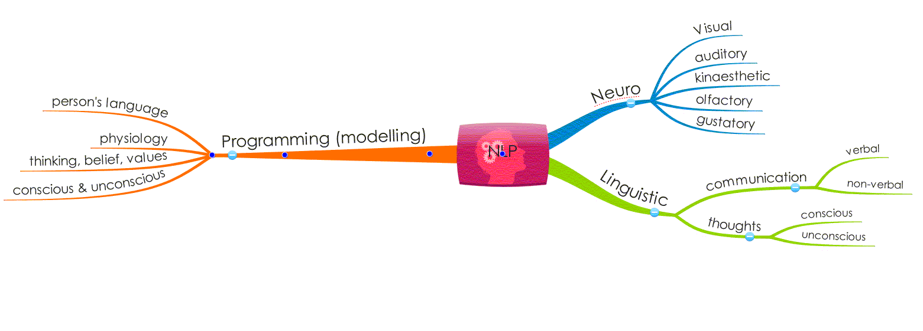

Chapter 1

1. present state $\underset{→}{NLP}$ desired state ⇒ produce new behavior
   1. reprogramme your unconscious mind
2. Four levels of change in learning
   1. unconscious incompetence
   2. conscious incompetence
   3. conscious competence
   4. unconscious competence – mastery
3. Four rules for success
   1. know what you want
      1. set final goal
      2. in which direction
      3. satisfaction
      4. specific way
   2. take action to get it
   3. be flexible
      1. try something different, take different actions
      2. find the right methods
   4. be aware
      1. sensory acuity – observe in detail
      2. aware in every situation
4. empowering beliefs for creating change
   1. a map is only a map
      1. his own view of the world, not the same territory
      2. your perception of the world
      3. perceptions are flexible and can be changed
   2. have respect for different models of the world
      1. different people, different ways of thinking
      2. respect these difference, to bridge the gap between
      3. effective communication
      4. what someone *does* is not the same as who that person *is*
   3. people work perfectly
   4. people make the best choice(s) available
      1. have made the best choices they can with their *current* abilities to use their *current* resources
   5. people already have the resources they need
      1. have ability to change our beliefs, goals and motivation
      2. have an attitude of flexibility and willingness to experiment to learn new skills
      3. *No* unresourceful people, *only* unresouceful states
   6. underlying every behavior is a positive intention
      1. unconscious works for our benefit, positive intention
   7. what you get is what you communicate
      1. Someone received a totally different message?
      2. Unable to persuade a colleague to do something?
      3. dialogue between individuals – feedback, think
      4. communication, verbal and non-verbal
      5. person who wants a result takes responsibility for getting that result
   8. Rapport and determines your successive communicating with another person
      1. ability to influence another person
      2. you perceive it to be in your interest
      3. feel so aligned with other person’s way of thinking
      4. don’t coerce or manipulate the person
   9. the person who is most flexible in his behavior has the best chance of success
5. Frameworks of thinking – behavioural frames
   1. outcome Vs blame (towards an outcome rather than a problem)
      1. blame frame – why
      2. outcome frame – how
      3. how Vs why – how you do what you do
   2. curiosity and experimentation
      1. curiosity: an attitude (ask lots of questions)
      2. experimentation: different ways of doing things → results
      3. assumptions: assumptions and expectations lead to pre-judging a situation
      4. choice: increase choice, open mind towards the world
      5. feedback Vs failure: focus on results, feedback on how near you are to the outcome you want (life is full of setbacks)
   3. failure

Belief in failure = lack of choice/being stuck

Belief feedback = learning, new choices, action then results

* 1. feedback: feedback leads to an attitude of flexibility + positive emotions

1. Possibility Vs Necessity
   * there are always choices available
   * cause rather than the effect of any situation
   1. cause and effect
      1. *At effect*: if we believe that we are affected by causes outside our control, we will not take responsibilities for the results we create → victims of fate
      2. *At cause*: if you decide to be at cause of whatever happens, you switch your thinking around and assume that you can influence what happens next

* What can I do differently to get the result I want?

$$\left(\begin{matrix}You & → & at effect \\ ↓ & & \\ at cause & & \end{matrix}\right)$$

Chapter 2