The Memory Book

- How memory works

  - Checking you memory

    - Link test
Read the following list of 20 items through once only, trying to memorize both the items and the order in which they are listed.
Wallpaper牆紙 | Scissors剪 | Power力量 | Perfume香水
Mountain山 | Nail指甲 | Elephant大象 | Safe保險箱
Skirt短裙 | Watch手錶 | Jail監牢 | Melon蜜瓜
String繩 | Nurse護士 | Mirror鏡 | Mongrel混血兒
Ice cream雪糕 | Plant植物 | Suitcase行李喼 | Engraving雕刻

    - Give yourself 60 seconds to memorize the following list of 10 items and their numbers. The aim of this test is to remember the items in random order, connecting them to their numbers. When your minute has passed, fill in the answers.
- Atom原子 | - Tree樹 | - Stethoscope聽診器 | - Sofa梳化 | - Alley巷
- Tile瓦 | - Windscreen擋風玻璃 | - Honey蜜糖 | - Brush刷 | - Toothpaste牙膏

    - Number test
Look at the four 15-digit numbers printed below, giving not more than half a minute of attention to each. At the end of each half minute, write down the sequence of numbers as best you can.

    - Telephone number test
The following is a list of ten businesses and people and their telephone numbers. Study the list for not more than two minutes and attempt to remember all the phone numbers, then answer the appropriate questions.
Name | Number | Name | Number
Body shop | 27875953 | My Mum | 57813702
Tennis partner | 66407336 | 嘉禾院線 | 21322132
天文台 | 1878200 | 大富豪 | 28284466
萬昌盛 | 22429111 | 童軍總會 | 23773300
花店 | 27258397 | 彩龍船 | 24952600

    - Card test
This test is designed to exercise your present capacity for remembering cards and their sequence. The list contains all 52 cards of a normal pack in numbered order. Your task is to spend no more than five minutes looking at this list, then recall it.

    - Face test
Look at these ten faces and names for not more than two minutes, then match the right name to the right face.

    - Dates test
This is your last test. Listed below are ten key historical dates. Give yourself two minutes to remember them all perfectly, then answer the questions.
 | 1666 | Great fire of London
 | 1770 | Beethoven’s birthday
 | 1215 | Signing of Magna Carta
 | 1917 | Russian Revolution
 | 1454 | First printing press
 | 1815 | Battle of Waterloo
 | 1608 | Invention of the telescope
 | 1905 | Einstein’s Theory of Relativity
 | 1789 | French Revolution
 | 1776 | American Declaration of Independence

  - Your memory’s rhythms: Recall during learning and recall after learning

    - Recall during a learning period
Start reading down the columns of words below:
was | the | range
away | of | of
left | Beyond | and
two | Leonardo da Vinci | and
his | which | else
and | the | the
the | must | walk
far | and | room
of | of | drawing
and | could | small
that | the | change

Once you have completed reading the list, cover it up and write down as many of the 33 words as possible below.

      - Check your recall
- 1 to 7 words from the beginning of the list
- 1 to 2 words from the end of the list
- most of words that appear more than once
- the outstanding word or phrase
- relatively few words from the middle of the list

      - Taking breaks is important
- short breaks gives highest recall performance, about 75%
- no break drops to 50% in the middle
- no break drops more for long time study

      - The rhythms of remembering
- A learning period of between 20-50 minutes produces the best relationship between understanding and recall
- Understanding yields better recalling?
- Recall and Understanding can work in maximum harmony
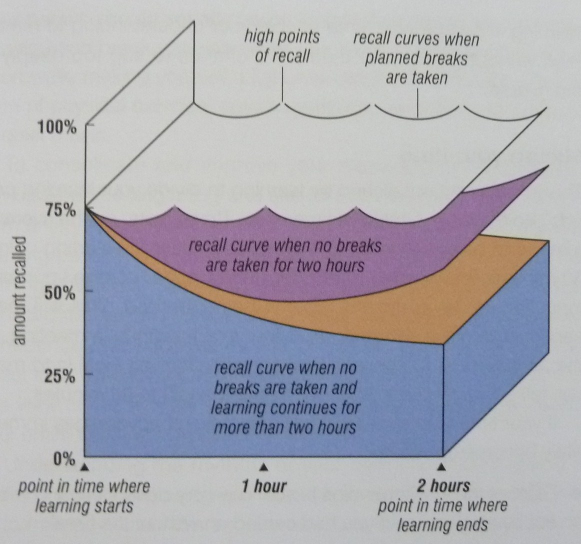
Slicing your time
- Take breaks
- Make more “beginning and ending” high points of recall
- Breaks yields both recall and understanding function more easily and efficiently
- Laid a firmer foundation from which you can then nourish and associate the new information, more connections
- Short walk, non-alcoholic drink, physical exercise, auto-suggesting, meditating, quiet music
- Consolidation, quick review, preview, continuing review-preview cycle
- Bird’s-eye view of the territory, imaginative links and associations

      - Recall after learning
- You retain more of what you have learned after a few minutes have passed since then end of your learning period
- Lose 80% of the detail you have learned within 24 hours of having learned it.

      - Review with repetition
- Repetitions, reviews, recalls
- From short-term memory into Long-term memory: STM ® LTM = 5R
- Shortly after → one day → one week → one month → three to six months
- “sort things out” & “back to the grindstone”
- “high point” occur approximately ten minutes after you stop
- Quick jotting down in Mind Map form; understanding and recall assist one another
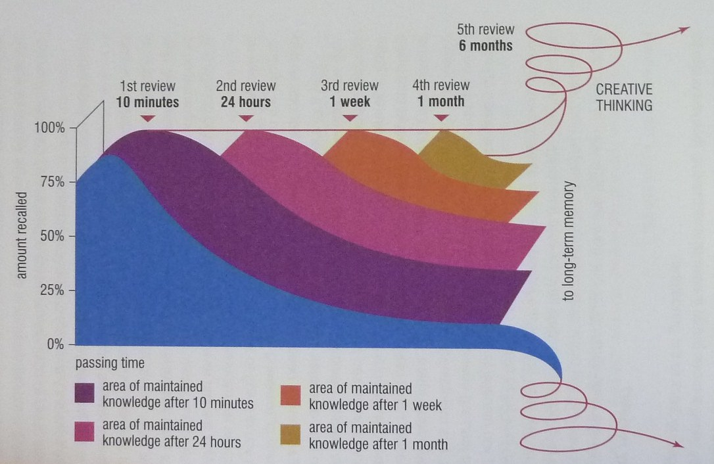
    - Age-proof your memory
- No indication show that human memory declines with age
- Aged people (over 24) do not use any memory techniques and did not do revision
- Left side brain: numerical, linguistic, analytical, logical, sequential abilities
- Right side brain: rhythmical, musical, imaginative, colourful, dimensional abilities
- The more it is fed, the more it will enable you to build up imaginative and associative networks with new areas of knowledge

  - The imagination and association principles and the 12 memory techniques
Mnemonics principles: imagination and association
Use your imagination and link in to association
      - The third memory principle
      - The 12 memory techniques: SMASHIN’ SCOPE: senses, movement, association, sexuality, humour, imagination, number, symbolism, colour, order and/or sequence, positive images, exaggeration
      - Key memory image words
      - Purity
        - Crashing things together
        - Sticking things together
        - Placing things on top of each other
        - Placing things underneath each other
        - Placing things inside each other
        - Substituting things for each other
        - Placing things in new situations
        - Weaving things together
        - Wrapping things together
        - Having things talk
        - Having things dance
        - Having things share their colour, aroma, action

  - The link system

    - Example: imagine that you have been asked to shop for the following items:

- A silver serving spoon鐵匙舀 | - Biological washing powder洗衣粉
- Six drinking glasses水杯六隻 | - Dental floss牙線
- Bananas香蕉 | - Wholemeal bread全麥包
- Pure soap肥皂 | - Tomatoes番茄
- Eggs雞蛋 | - Roses玫瑰

Record your list:

    - Superlinking the planets of our solar system
Check your knowledge and experience:
- Did you learn the planets of the solar system and, if so, how many times and over what period of time?
- Do you know the currently accepted number of planets in the solar system?
- Do you know their names?
- Do you know the normal order of the planets in the solar system?
Write down the names of all the planets of our solar system.

    - Memorizing the planets of our solar system
      - Mercury: liquid metal thermometer
      - Venus: beautiful little goddess
      - Earth: she is living with you surrounded by garden
      - Mars: a red-faced, angry and war-like character is your neighbor
      - Jupiter: next is your best friend with a giant cow-lick “J” on his forehead
      - Saturn, Uranus, Neptune: Jupiter is wearing a T-shirt with a big word “SUN” emblazoned in flashing gold letters
      - Pluto: a Walt Disney dog sitting nearby Jupiter
If your brain holds information in an organized and memorable matrix, each new bit of information will automatically link to the existing information, naturally building into the patterns of recognition, understanding and memory that we call knowledge. New information will be linked upon the basic memory and knowledge structures. We can look forward to a life of increasing memory skills, expanding knowledge, accelerating ease of learning and, as a consequence of all these, greater mastery of our memory and greater fun.

  - The number-shape system

    - Peg systems
A peg system can be thought of much like a wardrobe containing a certain definite number of hangers on which you hang your clothes. The hangers themselves never change, but the clothes that are hung on them vary infinitely.

    - How the number-shape system works
      - Create your own system because minds are infinitely varied.
      - The associations and images you generate will last far longer and that could be “implanted”.
      - Numbers have their own shapes.
      - Give yourself not more than ten minutes to complete the list from 1 to 10.
Number | Generic | Your own words
1 | Paintbrush
2 | Swan
3 | Heart
4 | Yacht
5 | Hook
6 | Elephant’s trunk
7 | Cliff
8 | Hourglass
9 | Balloon on a stick
10 | Bat and ball

      - Number-shape memory test
- Mentally link the number with the number-shape key image you have selected and drawn.
- Then hear, experience, taste or smell them.
- Run through the numbers in reverse order.
- Pick out the numbers randomly and, as quickly as you can, recall your images, making a game to see just how quickly each comes to mind.
- Reverse the whole process by flashing the images on you internal plasma screen.

      - Try to remember the following list of items:
- Symphony:
- Prayer
- Watermelon
- Volcano
- Motorcycle
- Sunshine
- Apple pie
- Blossoms
- Spaceship
- Field of wheat

      - Exaggeration, imagination, sensuality and creative thinking.
      - Make the wildest, most colourful and exaggerated associations possible, projecting your images on to your internal screen, and thus consolidating them as you progress.

  - The number-rhyme system

    - How the number-rhyme system works
      - Resemble the shape of the number, devise key memory images for words that rhyme with the sounds of the words for the numbers.
      - Make them imaginative, colourful and sensual.
      - Suggestions:
- One: bun, sun, nun, Hun, run, fun
- Two: shoe, pew, loo, crew, gnu, coo, moo
- Three: tree, flea, sea, knee, see, free
- Four: door, moor, boar, paw, pour
- Five: hive, drive, chive, dive, jive
- Six: sticks, bricks, wicks, kicks, licks
- Seven: heaven, Devon, leaven
- Eight: skate, bait, gate, ate, date
- Nine: vine, wine, twine, line, dine, pine
- Ten: hen, pen, den, wren, men, yen
      - Draw your images in the spaces provide

    - Number-rhyme memory test
      - Test yourself on your chosen key rhyming images.
      - Run through the list from 1 to 10 in the usual numerical order.
      - Next, run through it in reverse order.
      - Then in random order.
      - Finally, pick the image “out of the air” and connect “their” numbers to them.
      - Repeat them, making each repetition faster and faster until you acquire such skill that your mind will instantaneously produce the image as soon as you think of the number.

    - Number-shape and number-rhyme memory test
      - Now you have two separate 1 to 10 systems. Decide which system you want to be which and immediately put it to the test.
- atom | - tree | - stethoscope | - sofa | - alley
- tile | - windscreen | - honey | - brush | - toothpaste
- glitter | - heater | - railway | - lighter | - wart
- star | - peace | - button | - pram | - pump

      - Below are three columns of 20 numbers. Complete each list, filling in next to the number the appropriate item from the list you have just memorized.

1 | 20 | 11
2 | 19 | 15
3 | 18 | 10
4 | 17 | 3
5 | 16 | 17
6 | 15 | 20
7 | 14 | 4
8 | 13 | 9
9 | 12 | 5
10 | 11 | 19
11 | 10 | 8
12 | 9 | 13
13 | 8 | 1
14 | 7 | 18
15 | 6 | 7
16 | 5 | 16
17 | 4 | 6
18 | 3 | 12
19 | 2 | 2
20 | 1 | 14

      - If at first it doesn’t work perfectly, it may be due to
- They are associations that you don’t like
- The associations are too close or too similar to each other
- Not enough exaggeration and imagination
- Not enough colour
- Not enough movement
- Weak links
- Not enough sensuality
- Not enough humour

  - The Roman room / memory palace system

    - Imagine this imaginary room
      - You imagine the entrance of your house and your room and then filled the room with as many objects and items of furniture as you chose.
      - Each object and piece of furniture serving as a link image, to which you attached the things you wished to remember.
      - The Roman room system is particularly amenable to the application o f the strengths of the left and right hemispheres of your brain.
      - The room can be entirely imaginary.
      - Things that please all your senses, items of furniture and objects of art you have always desired to possess in real life, foods and decorations that especially appeal to you.
      - Both your memory and creative intelligence will begin to work paraconsciously on ways in which you can actually acquire such objects in real life.

    - Your Roman room
      - On a piece of paper jot down quickly your first thoughts on the items that you would like to have in your own room, the shape and design of the room.
      - Draw your ideal memory room (on a separate sheet of paper), either as an artist’s daring or architect’s plan, drawing and writing in the names of items with which you are going to furnish and decorate it.
      - Select ten specific “loci” or locations for your memory items, building up to 20, 30, 50, adding rooms to your house.
      - Take a number of “metal walks” around your room, memorizing precisely the order, position and number of items in the room and, similarly, sensing with all your senses the colours, tastes, textures, smells, scents or aromas and sounds within your room, using the whole range of your brain’s abilities.
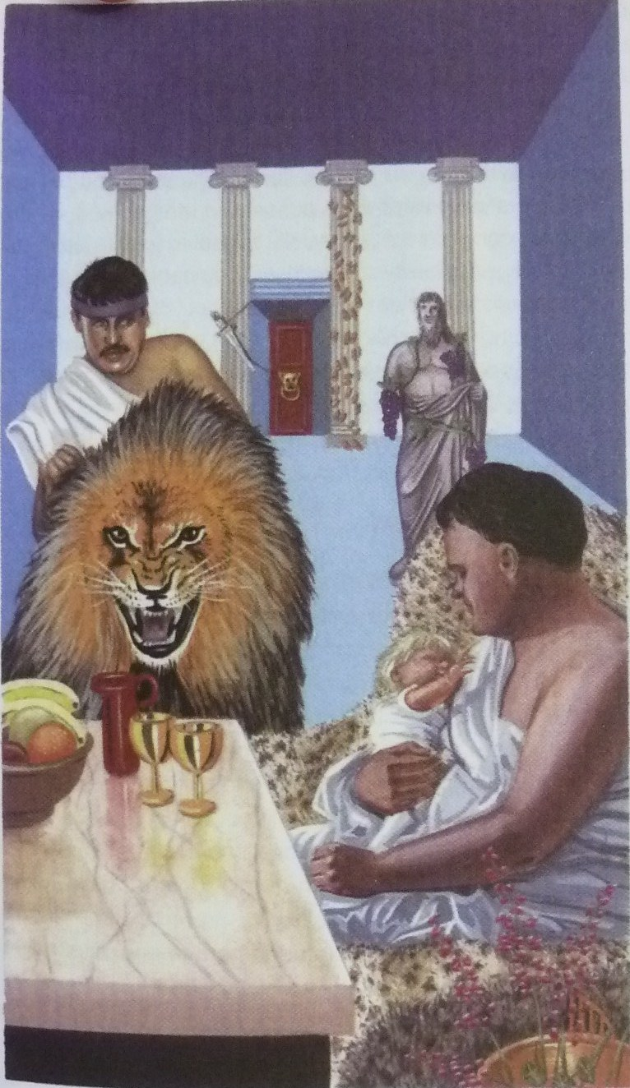
  - The alphabet system

    - Rules for constructing your alphabet memory system are simple:
      - Select a key memory image word that starts with the sound of each letter
      - Make sure the word is easy to remember
      - Make sure the word is easy to imagine
      - Make sure the word is simple to draw
      - If the letter itself makes a word when you say it (e.g. “I” makes the word “eye”, “J” jay)

    - Construct your alphabet system
      - pencil in your own initial alphabet system image words in the spaces provided
      - recheck your alphabet image words
      - select your final list and draw your images for them in the blank squares
      - when you completed your alphabet image word drawings, review them in exactly the same way as your have the previous memory systems

    - Suggested alphabet image words
- Ace | - Bee | - Sea | - Deed
- Easel | - Effervescence | - Jeep or Jeans | - H-bomb
- Eye | - Jay | - Cake | - Elastic
- MC | - Enamel | - Oboe | - Pea
- Queue | - Arch | - Eskimo | - Tea
- Yew | - Vehicle | - WC | - X-ray
- Wife | - Zebra

    - Double your memory power
      - Introductory memory systems: link, number-shape, number-rhyme, Roman room and alphabet.
      - They can be used either independently or in conjunction with another.

    - Icecubes
      - The words you associated were contained in a huge block of ice.
      - This visualization technique will drastically change the association pictures your have formed and will double the effectiveness of your system.

    - The ice factor in action

  - The major system

    - The major system’s special code
      - Make use of a different consonant or consonant sound for each number from 0 to 9 using a special code.
      - Number = associated code
 | = s, z, soft c | ‘s,’ or ‘z’, the first sound of the word “zero”, “o” is the last letter.
 | = d, t, th | ‘d’, ‘t’, have one downstroke
 | = N | ‘n’ has two downstrokes
 | = M | ‘m’ has three downstrokes
 | = r | ‘r’, the last letter in the word ‘four’
 | = L | ‘l’, can be thought of as either the Roman numeral for ‘50’ or an open hand, the index finger and thumb forming an ‘L’ shape
 | = j, sh, soft ch, dg, soft g | ‘j’, he mirror image of ‘6’
 | = k, hard ch, hard c, hard g, ng, qu | ‘k’, when seen as a capital, contains five number ‘7’s
 | = f, v | ‘f’, when handwritten, has two loops, similar to the number ‘8’
 | = b, p | ‘b’, ‘p’, the mirror image of ‘9’

      - The vowels a, e, i, o, u and the letters h, w and y do not have numbers associated with them. They are used as “blanks” in the key memory image words.
      - Create a key memory image word that can be immediately and permanently linked with the number it represents.
      - In selecting the ‘best’ words for this number, make use of the alphabet order to assist both in choice of word and in recall by using vowels letters.
      - The advantage of using this alphabet order system is that it can actually be ‘worked out’ from the basic information.

    - Initial major system exercise
      - Try to complete the words for numbers 10 to 19 in the table below using the alphabet order system.
      - Don’t just accept them, though – check each one carefully.
      - Use a strong noun or verb as it creates a good memory image on which to hang your information.

      - Initial 101 memory image words for the major system
- saw | - day | - Noah | - ma | - ra
- law | - jaw | - key | - fee | - bay
- daze | - dad | - dan | - dam | - dairy
- dale | - dash | - deck | - daffy | - dab
- NASA | - net | - nan | - name | - nero
- nail | - niche | - nag | - navy | - nab
- mace | - mat | - man | - ma’am | - mare
- mail | - mash | - mac | - mafia | - map
- race | - rat | - rain | - ram | - Ra-ra
- rail | - rage | - rack | - rafia | - rap
- lace | - lad | - lane | - lamb | - lair
- lily | - lash | - lake | - laugh | - lab
- chase | - chat | - chain | - chime | - chair
- cello | - cha-cha | - check | - chaff | - chap
- case | - cat | - can | - cameo | - car
- call | - cage | - cake | - cafe | - cab
- face | - fad | - fan | - fame | - fair
- fall | - fish | - fag | - fife | - fab
- base | - bat | - ban | - bam! | - bar
- ball | - bash | - back | - beef | - babe
- daisies

    - devising your own memory image words for numbers 101 to 1000
      - an alternative method is to stick with making every number into a letter and making a key memory image word from that combination of letters.
      - After certain of the more difficult words it has included:
        - A suggestion for a way in which an image might be formed from the word
        - Or a dictionary definition of the word, the definition including words or ideas that should help you form your image
        - Or ‘new’ definitions for words that place them in a humorous or unusual but certainly more memorable form
      - In the spaces provided you should write in your own key words for, or ideas about, the images you will be using.
      - If the combination of letters makes the use of single words difficult, double words have been used, such as ‘no cash’ for the number 276 (‘n’, hard ‘c’, ‘sh’)
      - In other cases it is necessary to include vowels (which have no numerical meaning) at the beginning of the word. The number 394 (‘m’, ‘p’, ‘r’) is represented by the word ‘empire’

    - Managing the major system when using this method
      - Check the major system list below carefully.
      - Making images for and remembering ten items each day.
      - Use both sides of your brain, increase and expand your imagination, creativity and awareness of your senses.
      - When words refer to ideas or concepts, take them to a more concrete level.
      - When words are similar in concept to previous words, make your images for them as different as possible.
      - Check words from a dictionary if you run into difficulty in selecting your key words. The suitable words must
        - Serve as a means of solidifying the images for you
        - Enable you to select the best possible images or words
        - Be of value in the improvement of your general vocabulary
        - Be of value in the improvement of your creativity
      - Memory image words for number 101 to 1000 (page 101)
    - How to increase everything you have learned so far by 1000 per cent
      - It is possible to create a memory system of large amount of words from basic words you have been absorbing.
      - Use the ice cube method. You simply coat, encase or colour sections of your major system with ice.
      - For each successive 100 you use a different ‘substance’.
      - Examples:
100-199 in block of ice
200-299 covered in thick oil
300-399 in flames
400-499 colored a brilliant and pulsating purple
500-599 made of beautiful velvet
600-699 completely transparent
700-799 smelling of your favorite fragrance
800-899 place in the middle of a motorway
900-1000 floating on a single cloud in a beautiful, sunny, clear blue sky

  - The card memory system

    - What is the secret?
      - Attach your key memory image for each card to the major system you have learned.
      - The first letter of the word for the suit as well as the number of the card in that suit; ‘c’ for club, ‘h’ for heart, ‘s’ for spade and ‘d’ for diamond.
      - The second consonant for the card word will be the consonant represented by the letter from the major system.

    - Memory image words for a standard pack of cards
      - Following are lists of the card and their memory image words.
Clubs |  | Diamonds |  | Hearts |  | Spades
CA | Cat | DA | Day | HA | Hat | SA | Sat
C2 | Can | D2 | Dan | H2 | Hen | S2 | Sin
C3 | Cameo | D3 | Dam | H3 | Ham | S3 | Sum
C4 | Car | D4 | Dare | H4 | Hair | S4 | Sear
C5 | Call | D5 | Dale | H5 | Hail | S5 | Sale
C6 | Cash | D6 | Dash | H6 | Hash | S6 | Sash
C7 | Cake | D7 | Deck | H7 | Hag | S7 | Sack
C8 | Café | D8 | Daffy | H8 | Hoof | S8 | Safe
C9 | Cab | D9 | Dab | H9 | Hub | S9 | Sap
C10 | Case | D10 | Daze | H10 | Haze | S10 | Seas
CJ | Cadet | DJ | Deadwood | HJ | Headed | SJ | Sated
CQ | Cotton | DQ | Deaden | HQ | Heathen | SQ | Satan
CK | Club | DK | Diamond | HK | Heart | SK | Spade
In this system, aces count as 1, the jacks and queens as 11 and 12, 10 counts as 0, the king as the name of the suit.

    - How does it word?
      - Whenever a card is called out, they associated that card with the appropriate number of the major system.
      - Using the major system as the pegs on which to hang the 52 items, you can clearly see that both the logical, analytical, sequential and numerical left side of your brain, and the imaginative, colourful, and rhythmical right side of your brain are being fully utilized.

    - How to increase your memory further still
      - Whenever a card is called out, you associate the image word for that card within a larger concept, such as the ice cube. When all the cards have been presented, run down the list of card memory words, noting those words that are not connected with the larger memory concept.
      - The other system for this kind of feat is to mutate, or change, in some way the card memory image word if that card is called.

  - Raising your IQ by using the long number memory system
Given a long number such as 95862190377 to memorize, most people will try a variety of strategies, including:
- Repeating the build-up continually as the number is presented, eventually getting bogged down in the very repetition process itself
- Subdividing the number into two or three number groups, eventually losing both the order and content of these
- Working out mathematical relationships between the numbers as they are presented, inevitably losing track of the original order or the numbers themselves
- Picturing the number as it is presented, the picture becoming more and more blurred as the long number is presented in its entirety
Instead of using the major system as a peg system for remembering list of 100 and 1000 you take advantage of its flexibility.

    - Pairing numbers with the major system’s memory image words
      - For example, 95862190377 is composed by 95-ball, 86-fish, 21-net, 90-base, 37-mac and 7-key
      - A brilliant, rainbow-colored ball bouncing with a loud ‘boing!’ off the head of a gigantic and beautifully colored fish that had just fought its way out of a very tangled and dripping-wet net, which was slowly collapsing to the base level of a pier, where it wrapped itself around a man wearing a fawn-colored and wind-blown mac, just as he was bending over to pick up a key, which he had dropped onto the pier with a loud clang.
      - Close your eyes and re-envision this little story.
      - Recalling the memory image words, transform them back into the numbers, and you will get:
b-9 l-5 f-8 sh-6 n-2 t-1 b-9 s-0 m-3 c-7 k-7 95862190377

    - Try it in threes
      - Try this with the number 851429730584
      - 851-fault 429-rainbow 730-cameos 584-lever
      - You can see in your mind some gigantic universal force that could cause a break or a fault in beautiful and shimmering rainbow-colored cameos, which are so heavy they need a gigantic lever to move them.
      - Close your eyes and show the little image story on your inner screen.
      - Recall the words and , transforming them, you get:
f-8 l-5 t-1 r-4 n-2 b-9 c-7 m-3 s-0 l-5 v-8 r-4 851429730584

    - Improvise
      - With a 16-digit number, such as 1582907191447620, you could make up the following 4-digit numbers and memory image words:
      - A red telephone, ringing loudly and melodically being thrown in a long and graceful parabolic curve into a basket, where an annoying person (a botherer) is jammed, bottom down (as in comedy films), while other people are throwing multicolored cushions in all kinds of different materials at him.
      - Close your eyes and imagine the story, then fill in the words and numbers in the space provided.

    - Using other pegging systems
      - Use both the Roman room system and the alphabet system, simply placing the words you had decoded from the long number either alphabetically or in your Roman room.

    - Some added benefits
      - Once you have mastered this skill, you will have improved your memory and your creative imagination even further and also actually raised your IQ.

  - The telephone number memory system

    - How to remember telephone numbers
      - ‘Translate’ each digit of the number you have to remember into a letter from the basic code for the major system.
      - Using the letters you have transcribed, make up catchy words and phrases that link you back to both the number and the person.

    - Solutions for difficult telephone numbers
      - Make up inappropriate words out of the numbers you have to deal with, then use the basic system, making absured and exaggerated images to link with the person whose telephone number you are trying to remember.
      - Example: one of your friends whose hobby is golf, is 491-4276. Then 49 (rap), 142 (drain) and 76 (cage).
      - Imagine that your friend rapping loudly on a drain, which has bars like a cage, with his golf club.

    - Over to you
      - In the space provided below, make a note of the names and telephone numbers of at least ten people or places you need to remember.

  - Memory system for schedules and appointments

    - Pegging your daily schedule
      - Either join shorter systems together , to make an appropriate total of 24, or use the firs 24 peg words in one of the larger systems.

    - Timetabling your weekly schedule
      - Take Sunday as day 1 of the week and ascribe a number to each of the other days:
      - Sunday-1, Monday-2, Tuesday-3, Wednesday-4, Thursday-5, Friday-6, Saturday-7

    - Simplifying the system
      - By ‘rotating’ the hours of the day to suit the times when you have most of your appointments.
      - For practical purposes, it is usually best to start with the system for your daily schedule, becoming skilled and familiar with it before moving on to the system for your weekly schedule.

  - Memory system for important historical dates
      - Make a word of the date.
      - In most cases, there is no point in including the ‘1’, representing the thousand.

  - Remembering birthdays, anniversaries and days

    - How the system works
      - The months are assigned the numbers 1 to 12 and given the appropriate memory image word for the major system.
January - Day | February - Noah | March - Ma | April - Ra
May - Law | June - Jaw | July – Key | August - Fee
September - Bay | October - Daze | November – Dad | December – Dan
      - Form an image that links the month and day words and the date you wish to remember.
      - Historical dates can become just as easy to remember.

  - Memory systems for vocabulary and language

    - Improving your word memory – general tips
      - Some more tips for how to improve your word memory.
        - Browse through a good dictionary, studying the ways in which the prefixes, suffixes and roots of the language are used. Whenever possible, use association to strengthen your recall.
        - Introduce a fixed number of new words into your vocabulary every day. New words are retained only if the principle of repetition, as explained earlier, is practiced. Use your new words in context and as many times as possible after you have initially learned them.
        - Consciously look for new words in the language. This directing of your attention, know as mental set, leaves the ‘hooks’ of your memory more open to catching new linguistic fish.

    - Improving your word memory – specifics
      - Associate sounds, images and similarities using the fact that certain languages are grouped in ‘families’ and have related words.
      - Imprint the words on your memory you can associate the sound of it with the phrase ‘Where to go?’
      - Foreign languages are more approachable when one realizes that they form groups.
      - All European languages (with the exception of Finnish, Hungarian and Basque) are part of the Indo-European group and contain a number of words that are similar in both sound and meaning.
      - A knowledge of Latin is of enormous help in understanding all the Romance languages, in which many of the words are similar.
      - Apart from Latin, Greek and French, the rest of English is largely Angle-Saxon, and German.
      - Learning languages need not be the frustrating and depressing experience it so often is.

    - The 100 basic words that make up 50 percent of all conversation
      - To get head start in learning is to realize that, in most languages, 50 percent of all conversation is made up of only 100 words.
      - Here below are the 100 most used words in different languages.
      - Adults can learn languages as well as children. Children simply open their minds more to the language and are not afraid to make mistakes.
      - They repeat and make associations with the basics, listen more attentively, copy and mimic and generally have a thoroughly good time without as much instruction as we adults think we need.

  - Remembering names and faces
Paul Smith | Roger Waters
Christian Dover | Sebastian Bach
Jackson Michael | Angry Bird
胡爾諾 | 李雲仇
郭德宏 | 曾義弓
劉寶玲 | 蔡茹玉
范憎祺 | 冼志錦
覃雪清 | 達也真彥
畢達哥拉斯 | Apfel Saft

    - The ‘social etiquette’ method
      - Two simple things of you:
        - An interest in the people you meet
        - Politeness
      - The rules being structured formally only to enable the people to meet and remember one another.
        - Mental set
        - Observe
        - Listen
        - Request repetition
        - Verify the pronunciation
        - Request the spelling
        - Your new hobby – derivations
        - Exchange cards
        - Repetition in conversation
        - Repeat internally
        - Check during longer breaks
        - Repetition at parting
        - Reviews
        - The reversal principle
        - Pace yourself
        - Have fun
        - The ‘plus one’ principle

    - The mnemonic names and faces memory method
      - The steps are as follows:
        - Make sure that you have a clear mental image of the name of the person you want to remember.
        - Make sure you can actually ‘hear again’ the sound of the person’s name.
        - Very carefully examine the face of the person you have been introduced to, noting in detail the characteristics outlined below.
        - Look for facial characteristics that are unusual, extraordinary or unique.
        - Mentally reconstruct the person’s face, using your imagination in the way that a cartoonist does to exaggerate any noteworthy features.
        - Associate – using your imagination, exaggeration and the 12 general memory techniques – any outstanding features with the name of the person.
        - Below are 20 faces and names on which you will be tested

    - Memorizing faces
      - Apply the techniques outlined, looking closely at the faces to find some characteristics that you could imaginatively associate with the name, then make your mnemonic image.

    - Short-term tip
      - If you are certain that you will be meeting a person only once and so are not concerned about committing his or her name and face to your long-term memory, use an outstanding item of clothing that the person might be wearing to remember him or her that day.

    - Head and facial characteristics
      - Head:
        - square, rectangular, round, oval, triangular, broad, narrow, big-boned, or fine-boned.
        - From the side view: square, rectangular, oval, broad, narrow, round, flat at the front, flat on top, flat at the back, domed at the back.
      - Hair
        - In earlier days, hairstyles used to be more consistent and long-lasting.
        - But nowadays, the advent of dyes, sprays, wigs and almost infinitely varied styles makes identification by means of this feature tricky business.
        - Men can have thick, fine, wavy, straight, parted, receding, bald, cropped, medium, long, frizzy, a particular colour or they can be bald.
        - Women can have thick, thin, or fine hair.
      - Forehead
        - High, wide, narrow between hairline and eyebrows, narrow from temple to temple, smooth, lined horizontally or lined vertically.
      - Eyebrows
        - Thick, thin, long, short, meeting in the middle, spaced apart, flat, arched, winged, bushy or tapered.
      - Eyelashes
        - Thick, thin, long, short, curled or straight
      - Eyes
        - Large, small, protruding, deep-set, close together, spaced apart, slanted outwards, slanted inwards or unusually colored eyes, with the entire circle of the iris visible or partially covered by the upper and/or lower lids.
        - Pay attention to the lid above and the bag below the eye, both of which can be large or small, smooth or wrinkled, puffy or firm.
      - Nose
        - Seen from front: large, small, narrow, medium, wide, or crooked
        - Seen from side: straight, flat, pointed, blunt, snub or upturned, Roman or aquiline, Greek or concave
        - Base: nostrils, lower, level or a little higher. The nostrils themselves can also vary be a variety of shapes – straight, curved down, flaring, wide or narrow.
      - Cheekbones
        - Cheekbones are often linked very closely with the characteristics of a face when seen front-on.
        - Are the cheekbones high, prominent or obscured?
      - Ears
        - Large, small, gnarled, smooth, round, oblong, triangular, flat against the head, protruding, hairy, large lobed, have no lobes or be uneven
      - Lips
        - Long upper lip, short upper lip or small, thick wide, thin, upturned, downturned, Cupid’s bow, well-shaped or ill-defined lips
      - Chin
        - Seen straight-on: Long, short, pointed, square, round, double (or multiple), cleft or dimpled
        - Seen from the side: jutting, straight, double (or multiple) or receding
      - Skin
        - Smooth, rough, dark, fair, blemished or marked in some way to oily, dry, blotchy, doughy, wrinkled, furrowed, colored, tattooed, tanned
      - Other features

    - A basic image list
      - In your basic image list, simply have some standard images for such names that you can immediately link to the outstanding facial characteristics of those who have those names. Following is a list of examples of names and images to illustrated how this is done.
        - Ashcroft the smouldering roff of a burned-out farm building with masses of flaky grey ash.
        - Blake a gigantic, limpid blue lake in the shape of the letter B.
        - Delaney a giant ripping out country lanes (de-lane-ing).
        - Evans vans shaped like the capital letter ‘E’, the spine of the letter being the top of the van.
        - Farren a tiny little bird (wren) seen from a long way away.
        - Goddard God with a ‘hard’ expression on his face.
        - Humphrey a delighted prisoner humming a happy song as he is let out from behind the bars.
        - Ivy ivy.
        - King a throne.
        - Lawrence of Arabia!
        - Mercer someone pleading for and being giben mercy.
        - Nunn nun.
        - Ovett a veterinary surgeon swinging in a gigantic letter ‘ O’.
        - Patterson the pitter-patter of your own child or htat of a friend as those little feet scyrry across the floor.
        - Quarry a gigantic open cast mining area showing a strongly colored ore.
        - Richardson the son of a ‘rich, hard’ father.
        - Scott a filt, haggis or anything typical, of a Scottish person.
        - Taylor a suit.
        - Underwood wood under which you place the image of the person, such as an old, gigantic fallen tree.
        - Villars a magnificent gleaming white Mediterranean villa.
        - Wade a person or animal wading thigh-high through a lake.
        - Xanthou ‘Thank you’
        - Young a springtime image.
        - Zimmermann someone ‘zimming’ (made up word for skimming/zooming) across the surface of water.
  - Catching your dreams

    - How to memorize your dreams
      - Retrieve the dream. Set your mind just before you go to sleep. Repeat yourself, ‘I am a dream rememberer, I am….’
      - It may take as many as three weeks before you ‘catch’ your first one.
      - Once you have caught a dream, you enter the second stage of dream memorization.
      - Don’t be so excited when you caught one because you will lose it. You must learn to maintain an almost meditational calm, gently reviewing the main elements of the dream.
      - Select two or three of the main images from the dream and attach these, using the memory techniques such as the basic peg or link system.

    - The benefits of being able to recall dreams
      - People who have started to remember their dreams show that, over a period of months, they become calmer, more motivated, more humorous, more imaginative, more creative and far better able to remember things generally.
      - Your para-conscious dream world is a constant playground for your whole set of cognitive skills, exercising the part of your brain, your cerebral cortex, where all of the 12 memory techniques are practiced to perfection.
      - Getting touch with these at the conscious level encourages all the connected skills to improve automatically.
      - Try to become a self-exploration and improvement dreamer. Keep a ‘dream diary’.

  - The self-enhancing master memory matrix (SEM³)

    - How does it work?
      - Use the ice cube idea
      - Based on the initial 100 memory image words used in the major system
      - The major system is considered to be in 2-D dimensions, SEM3 adds another dimension
      - Incorporating all of your senses of vision, sound, smell, taste, touch and sensation
000-999 | Vision
1000-1999 | Sound
2000-2999 | Smell
3000-3999 | Taste
4000-4999 | Touch
5000-5999 | Sensation
6000-6999 | Animals
7000-7999 | Birds
8000-8999 | The rainbow
9000-9999 | The solar system
      - For 0 to 999, use vision – focus on seeing the images you wish to remember as your key means of remembering them, etc.
      - For each group of 100 within each 1000, assign a specific vision, a specific sound…
      - First letter of each of these words corresponds to the consonant sounds of the major system.
Thousands |  | 0-99 | 100-199 | 200-299 | 300-399 | 400-499 | 500-599 | 600-699 | 700-799 | 800-899 | 900-999
100-999 | Vision |  | Dinosaur | Nobility | Moonlight | Ravine | Lightning | Church | Concorde | Fire | Painting
1000-1999 | Sound | Sing | Drum | Neigh | Moan | Roar | Lap | Shh | Gong | Violin | Piano
2000-2999 | Smell | Seaweed | Tar | Nutmeg | Mint | Rose | Leather | Cheese | Coffee | Forest | Bread
3000-3999 | Taste | Spaghetti | Tomato | Nuts | Mango | Rhubarb | Lemon | Cherry | Custard | Fudge | Banana
4000-4999 | Touch | Sand | Damp | Newspaper | Mud | Rock | Lather | Jelly | Grass | Velvet | Bark
5000-5999 | Sensation | Swimming | Dancing | Nuzzling | Mingling | Rubbing | Loving | Shaking | Climbing | Flying | Peace
6000-6999 | Animals | Zebra | Dog | Newt | Monkey | Rhinoceros | Elephant | Giraffe | Kangaroo | Fox | Bear
7000-7999 | Birds | Seagull | Duck | Nightingale | Magpie | Robin | Lark | Chicken | Kingfisher | Flamingo | Peacock
8000-8999 | Rainbow | Red | Orange | Yellow | Green | Blue | Indigo | Violet | Black | Grey | White
9000-9999 | Solar system | sun | mercury | Venus | earth | mars | Jupiter | Saturn | Uranus | Neptune | Pluto
      - For example, 101 corresponds to 1 in the list of the initial 101 memory image words might be a giant dinosaur with its head rising above the horizon next to the sun at the beginning of a new day, while 140 corresponds to 40 so your same dinosaur could be leading an incredibly noisy, thundering and exciting dinosaur race.
      - When playing the game of creating your images make sure that you emphasize the sense

    - The benefits of SEM3
      - Enable you to memorize an unlimited number of items on 10,000 hooks and also be training each one of your sensory areas.
      - Positive spiral as the more you practice your memory techniques, the more your general memory will improve.
      - The more you add your knowledge lists to your memory matrix, the more you will be increasing the probability of automatic learning.
      - The more you do all this, the more automatically all of your various intelligences and mental skills will be improved.

