請就以下各圖，寫出該圖應該是屬哪個月份的天氣。（選擇：1/2月、3月、6月、7月、8月、9月、11月、12月）
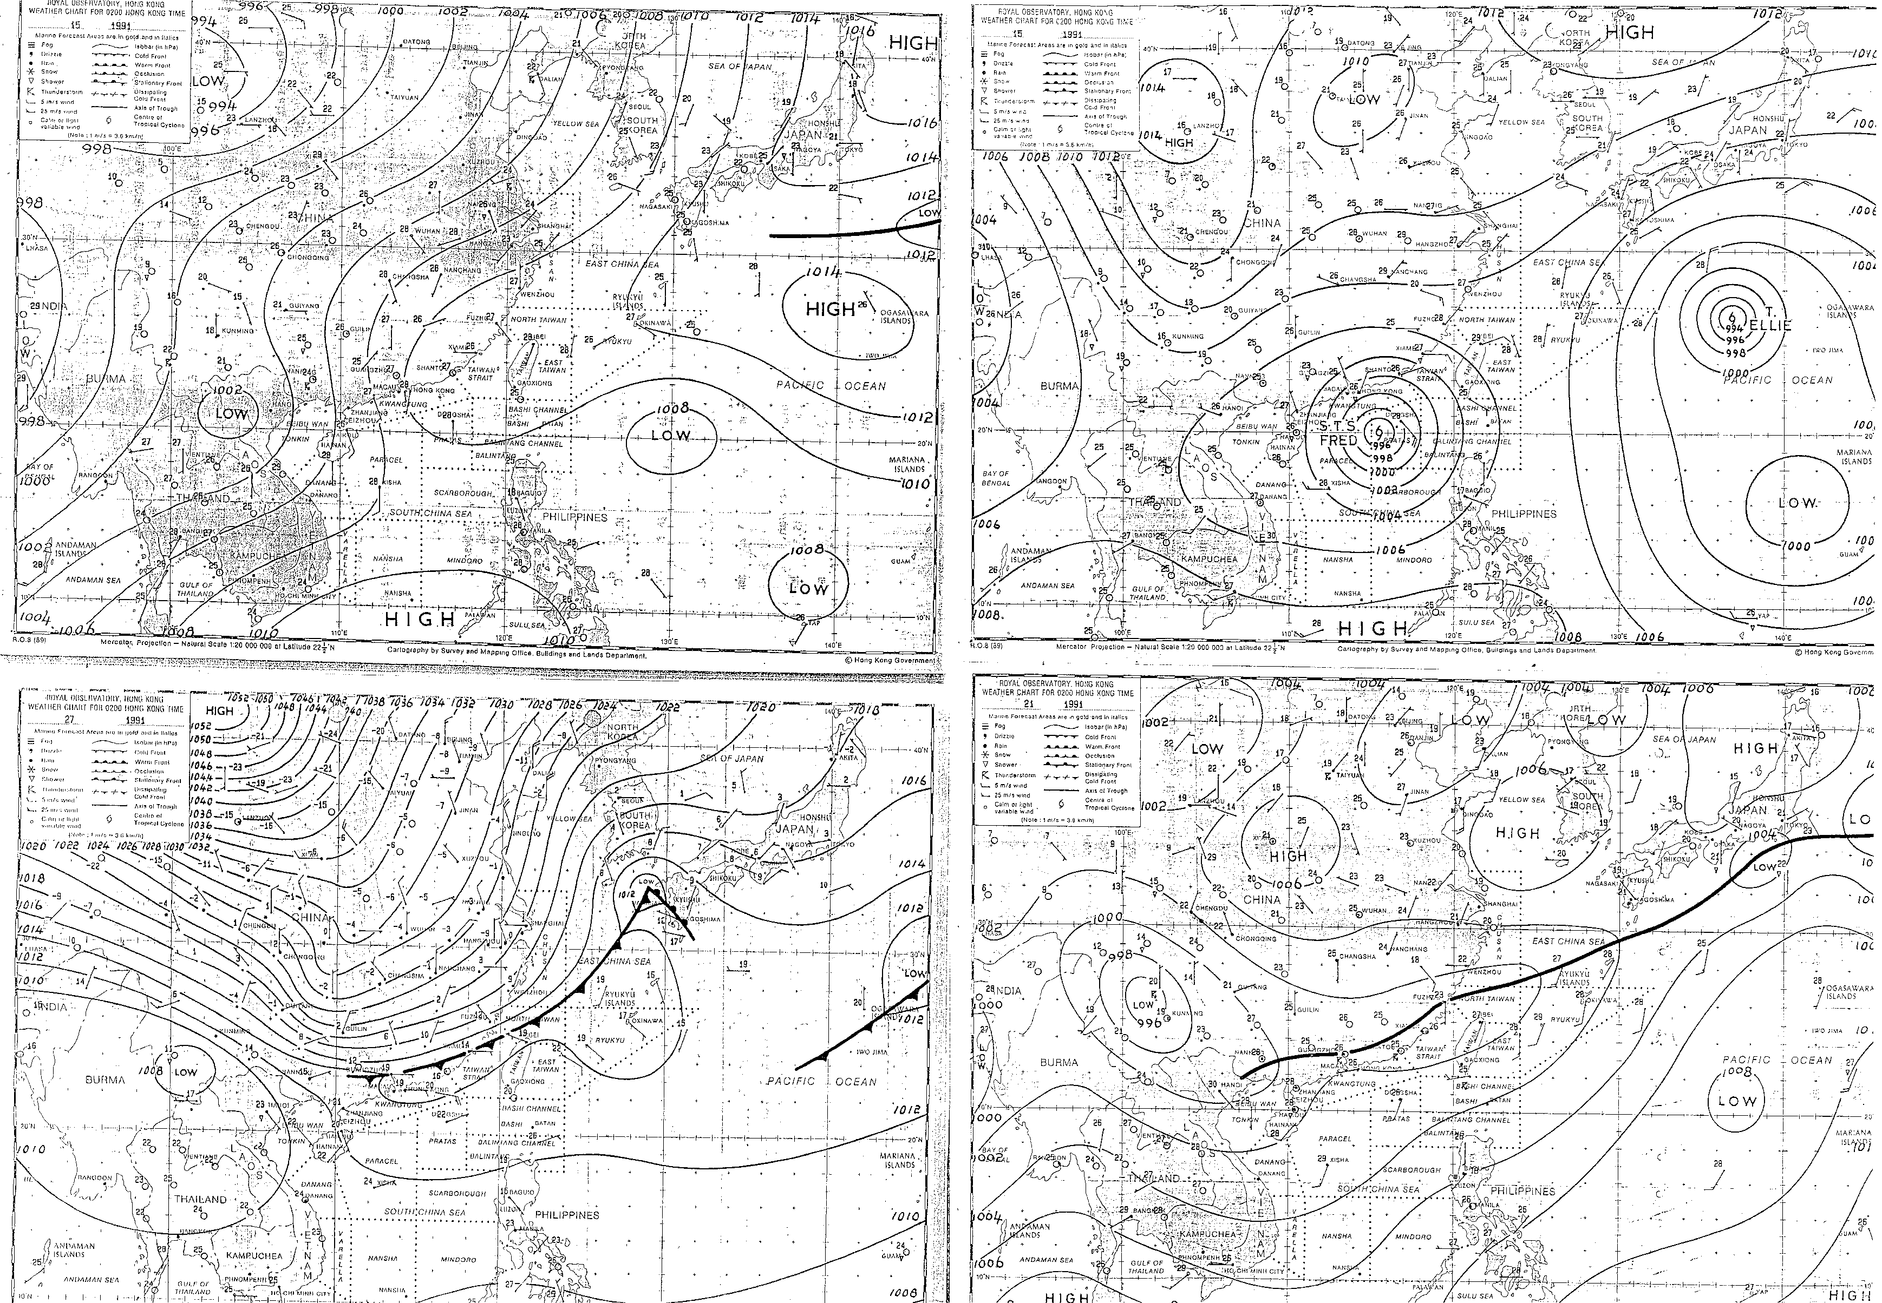
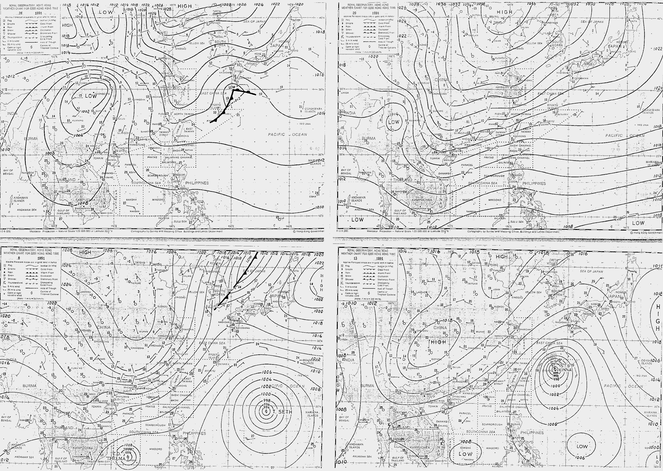
答案
1. | 2.
3. | 4.
5. | 6.
7. | 8.

July (mid-summer)  At the beginning of July, subtropical ridge STR persisted to the south china coast and brings good weather. | August (TC season)  Tropical cyclone attack south china coast. The frequency of TC attack is highest among the 12 months.
December (mid-winter)  Very great pressure gradient persisted to HK due to mid-China High. Cold front and Northerly wind are common. | June (early summer)  Southwesterly monsoon is common in May and June due to the Low at the southwestern. Trough and heavy rain will happen among the 12 months
March (spring)  Easterly wind due to the High at northeasterly brings humid air and cause fog. | January/February (late winter)  The mid-China High will move to the east instead of southerly brings northeasterly wind. Comparatively warm than December.
November (autumn)  Mid-China High starts developed after summer brings northeasterly wind, dry and cool, but not cold, very good weather among the 12 months. | September (late summer)  After August, the path of TCs is recurving or moving westerly instead of a head on to the south China. Weak High dominated China.

